**1. Use the Previously Created Linux VM**

* **In Azure Portal**:
  1. Go to "Virtual Machines."
  2. Select the previously created **Linux VM**.

**2. Install Apache2 on This VM**

* **Via SSH**:
  1. Connect to your Linux VM using SSH. In your terminal, run:
  2. Once logged in, update the package list:

**sudo apt update**

* 1. Install Apache2:

**sudo apt install apache2 -y**

* 1. Start and enable Apache2 to run on boot:

**sudo systemctl start apache2**

**sudo systemctl enable apache2**

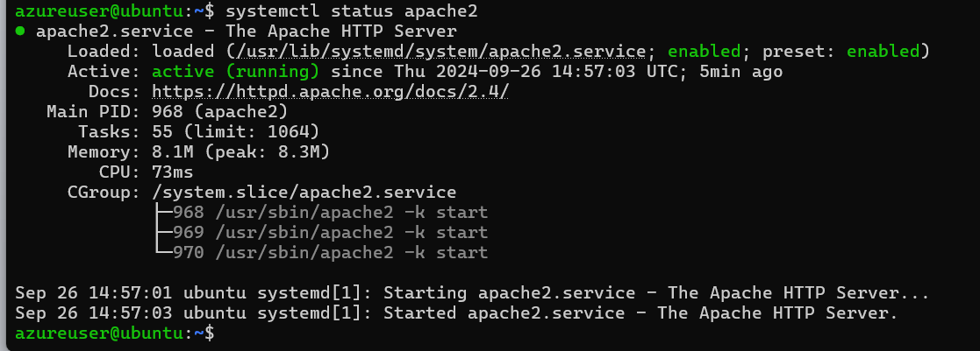

**3. Create a Network Security Group (NSG) for the Subnet**

* **In Azure Portal**:
  1. Navigate to "Network Security Groups."
  2. Click "Create."
  3. Enter a name for the NSG and select the appropriate **resource group** and **region** (same as your VM).
  4. Click "Review + Create," then "Create."

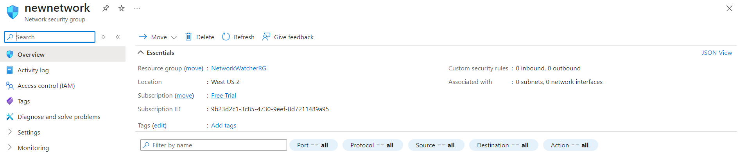

**4. Open NSG Rules for Subnet and VM on Port 80**

* **In Azure Portal**:
  1. After the NSG is created, go to the **NSG** and select **Inbound Security Rules**.
  2. Click "Add" to create a new inbound rule:
     + **Source**: Any
     + **Source port ranges**: *
     + **Destination**: Any
     + **Destination port ranges**: 80
     + **Protocol**: TCP
     + **Action**: Allow
     + **Priority**: Provide a number (e.g., 100)
     + **Name**: Open-Port-80

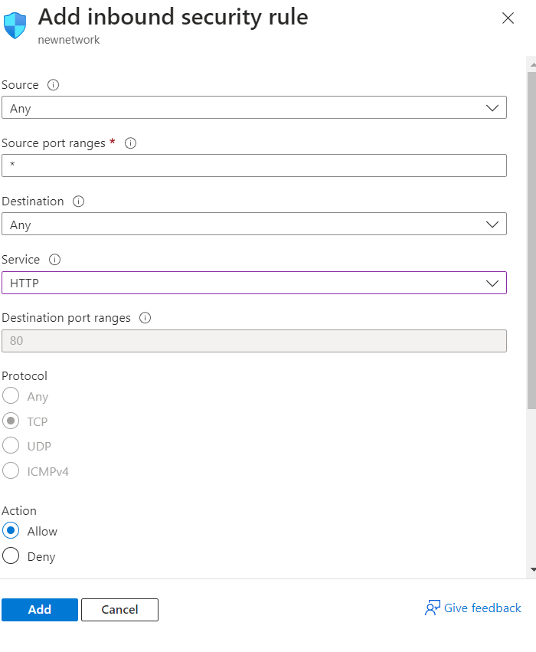

* 1. Click "Add" to apply the rule.
  2. Associate the NSG with the subnet where the VM is deployed:
     + In the NSG, click on **Subnets** under "Settings."
     + Select the subnet of your VM’s virtual network and click "Save."

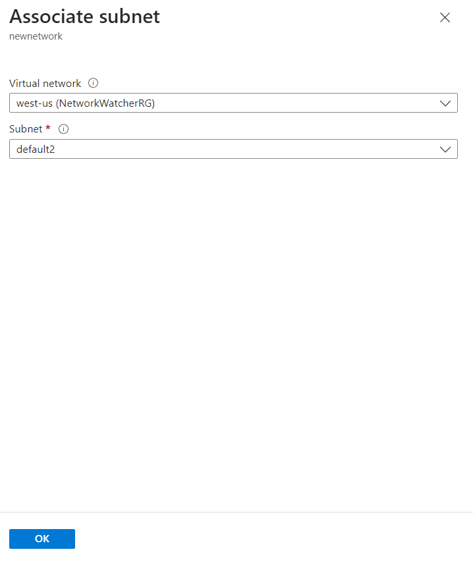

**5. Verify If You Can See the Apache2 Page**

* **In Your Browser**:
  1. Open a browser and go to http://<VM-public-IP>.
  2. You should see the Apache2 default page.

